**PMAS Arid Agriculture University Rawalpindi**

***Due Date: 7, March. 2022***

**University Institute of Information Technology**

**Assignment No. 1**

**Important Note:**

Copying/Cheating whole or part of the assignment from anywhere will not be tolerated. Whether you have copied or your work has been copied by someone else, you will get zero marks in that assignment. The assignment should be hand written.

**Question 01**

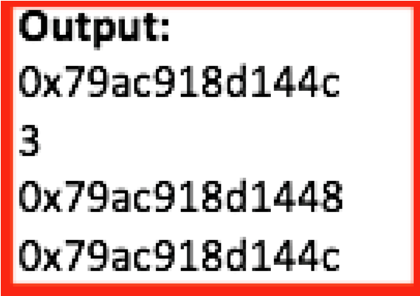Assuming there is no error, without changing the existing code, fill the 3 lines with suitable statements for the output given on right side:

int main()

{ int var1 = 3; //Address of var1=0x79ac918d1444 int var2 = 24; //Address of var2=0x79ac918d1448 float var3 = 17.5; //Address of var3=0x79ac918d144c

----------

----------

----------

cout << fptr<<endl << *iptr<<endl << vptr<<endl; vptr=&var3; cout <<vptr; }

**Question 02**

Write a C++ program which initializes a two-dimensional array **A** in the main function with the values shown in the right table. Pass this array from main function to a user defined function **display (),** which will count and display the total no of odd, even, positive and zeros present in the given array. Overload the display function by passing an additional arguments **X and Y** of type int, which will return value present at Xth row and Yth column of the 2-D array.

# Question 03

Write a C++ program that inputs 50 student’s data (with unique arid no.) and displays result in the following format using **display()** function. Please note that the Total, %age and grade will be calculated at run time using (A grade for >=80%, B for >=65%, C for >=50%, D for >=32% and F for less than 32%). Once the input is done then call the **sort ()** function which Sort the students on the basis of %age and finally call the **classSummary()** function which displays the record of topper of the class and class average.

|  |  |  |  |  |  |  |  |  |
| --- | --- | --- | --- | --- | --- | --- | --- | --- |
| St# | AridNo | StName | Subject1 | Subject2 | Subject3 | Total | %age | Grade |
| 1 | 21-arid-1234 | Ali | 80 | 90 | 70 | 240 | 80.00 | A |
| 2 | 21-arid-2145 | Ahmad | 70 | 65 | 75 | 215 | 70.00 | B |
| --- |  | --- | --- | --- | --- | --- | --- | --- |

# Question 04

Write a C++ program to accept a 3 X 4 matrix having integer values. Accept another 4 X 3 matrix having integer values. You are required to multiply these matrices and display the resultant matrix.



**Question 05**

**(**

**)**

Pakistan Super League (PSL) is

in prog

ress

now a days and below is

the

latest

table

points

.

play

teams

both

mean

Ties

Where

ed

equally

and NR means No

Result

of the match

.

F

o

r

Won 2 p

oints

to the winning team

and for Ties 1 point is given to

each

team.

Organizers contacted you to autom

ate the Points Table for quick

access and do the following tasks

:

A)

Based on the

above

points table, w

rite a structure

**Team**

,

which can hold all necessary variables

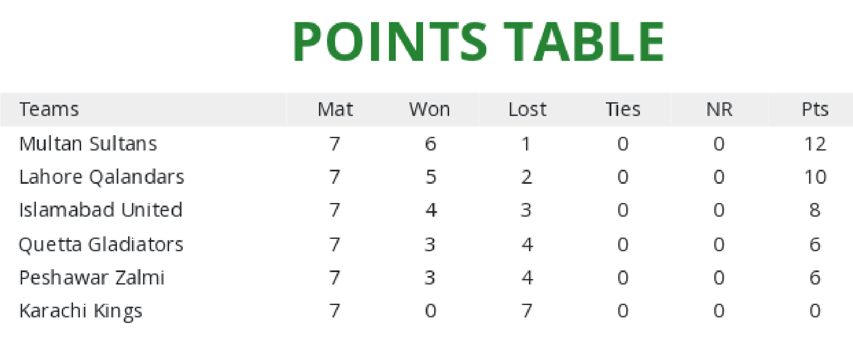

(not all) to store data.

1. Write a **display(Team [ ])** function which display all above information as shown in table.
2. Write a function **writeData()** which gets all above 6 records from user and write in a file **“Records.txt”** in an overwrite mode. Please note that name will be stored in a file by joining both words of name with underscore, e.g. Multan_Sultans
3. Write a function **readData()** which read all records from a file **“Records.txt”** and display it using display(Team [ ]) function defined in B) part. Please note that during display underscore should not

be visible.